# CS 255 DriverPass System Design Document

Brooks Maerder

10/18/25

## UML Diagrams

### UML Use Case Diagram

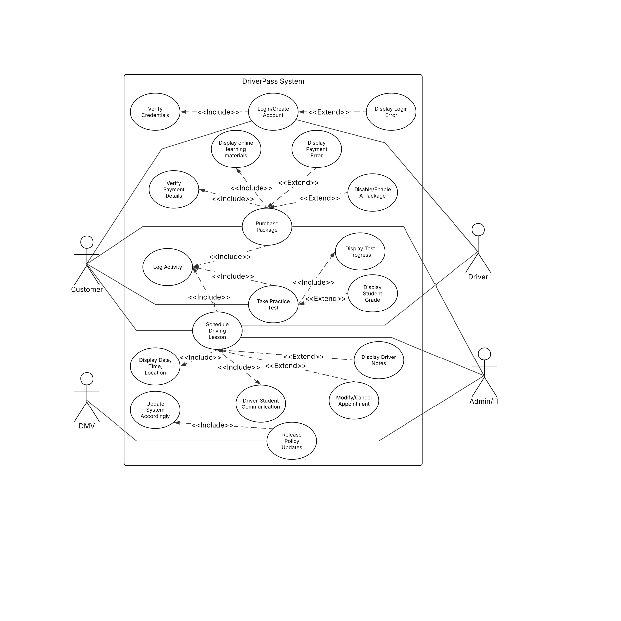

### UML Activity Diagrams

Activity Diagram #1 - User Login

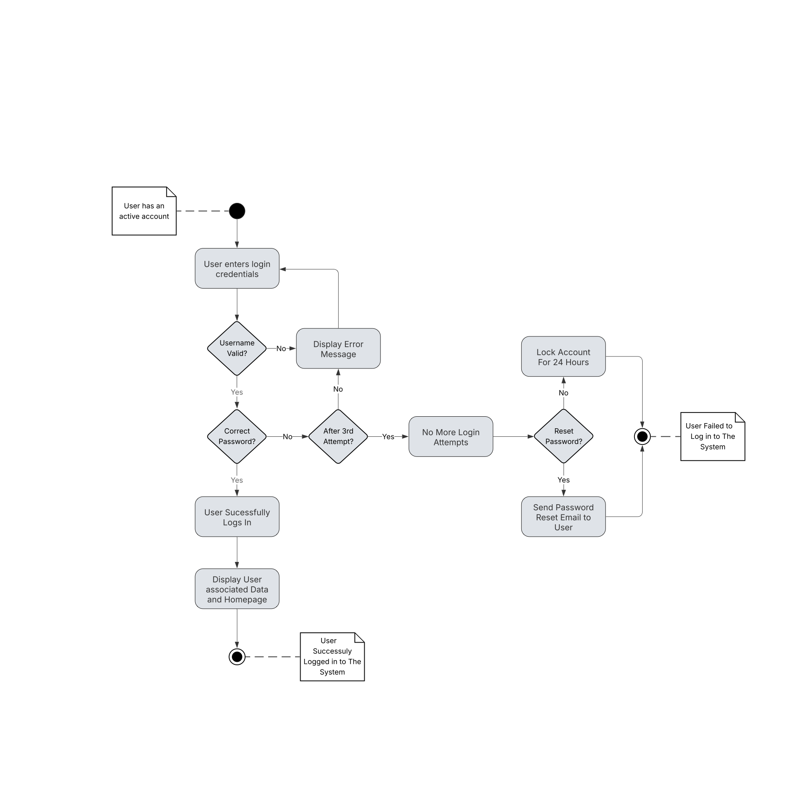

Activity Diagram #2 - Purchase Package

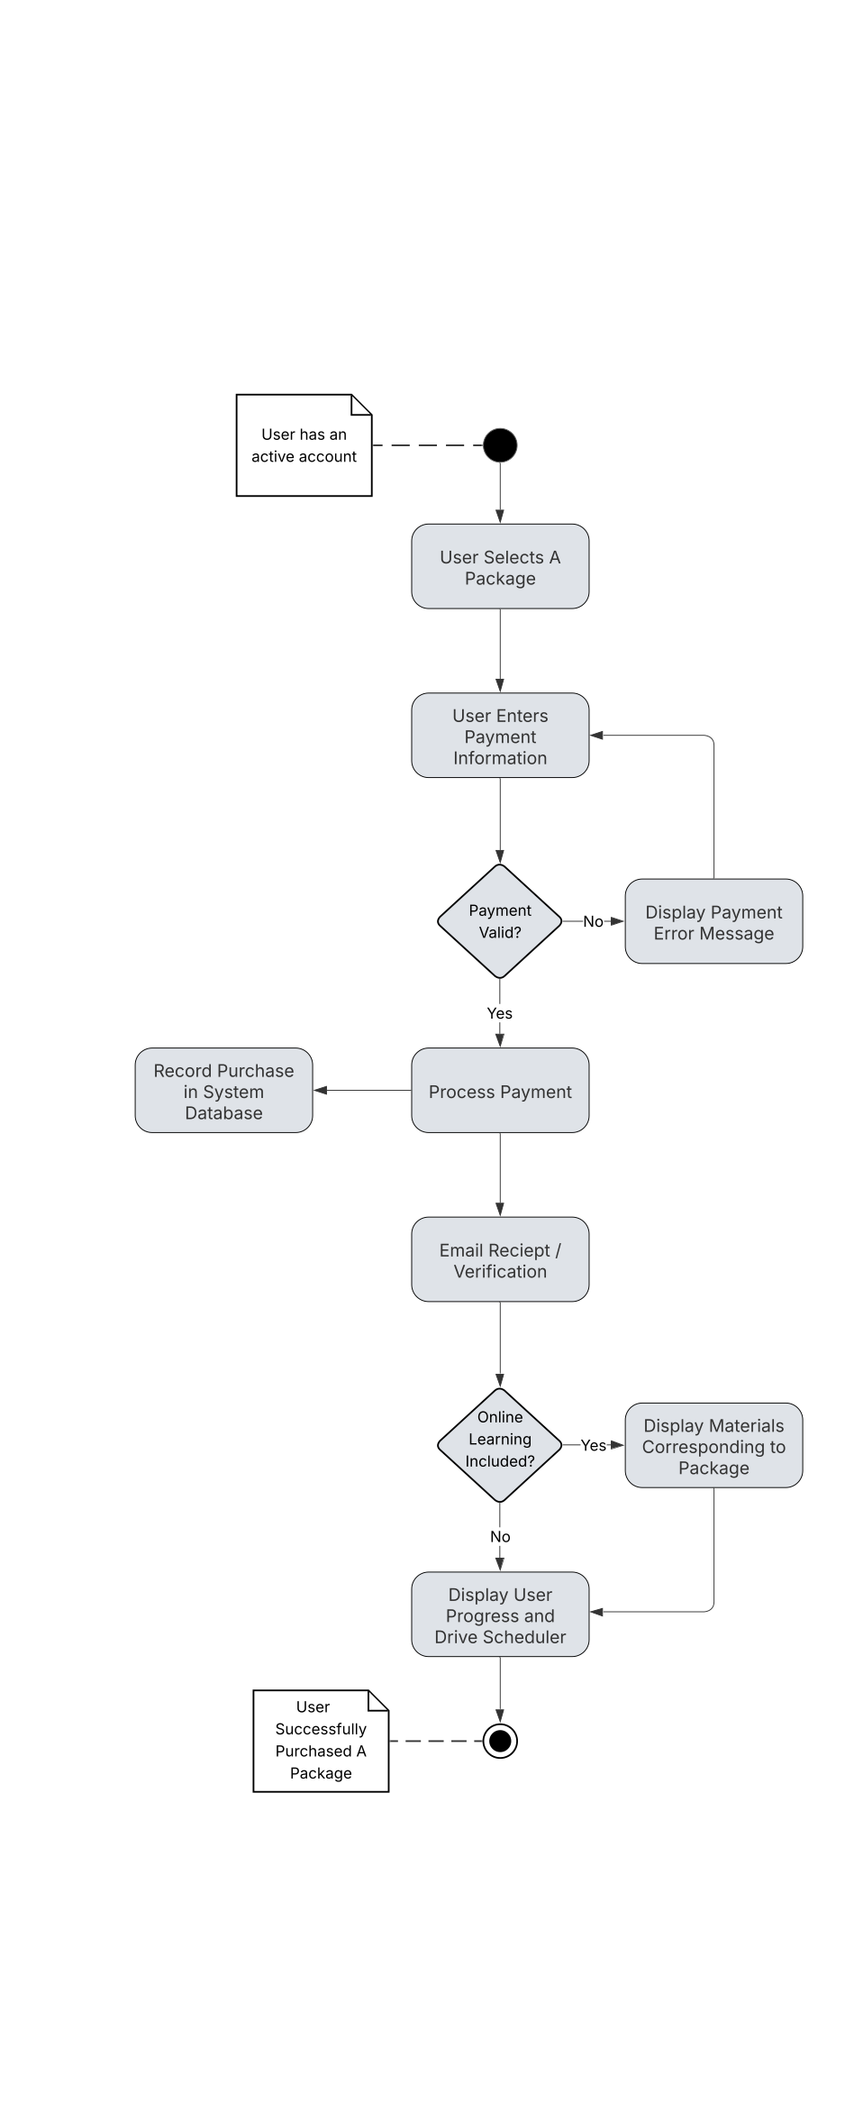

### UML Sequence Diagram

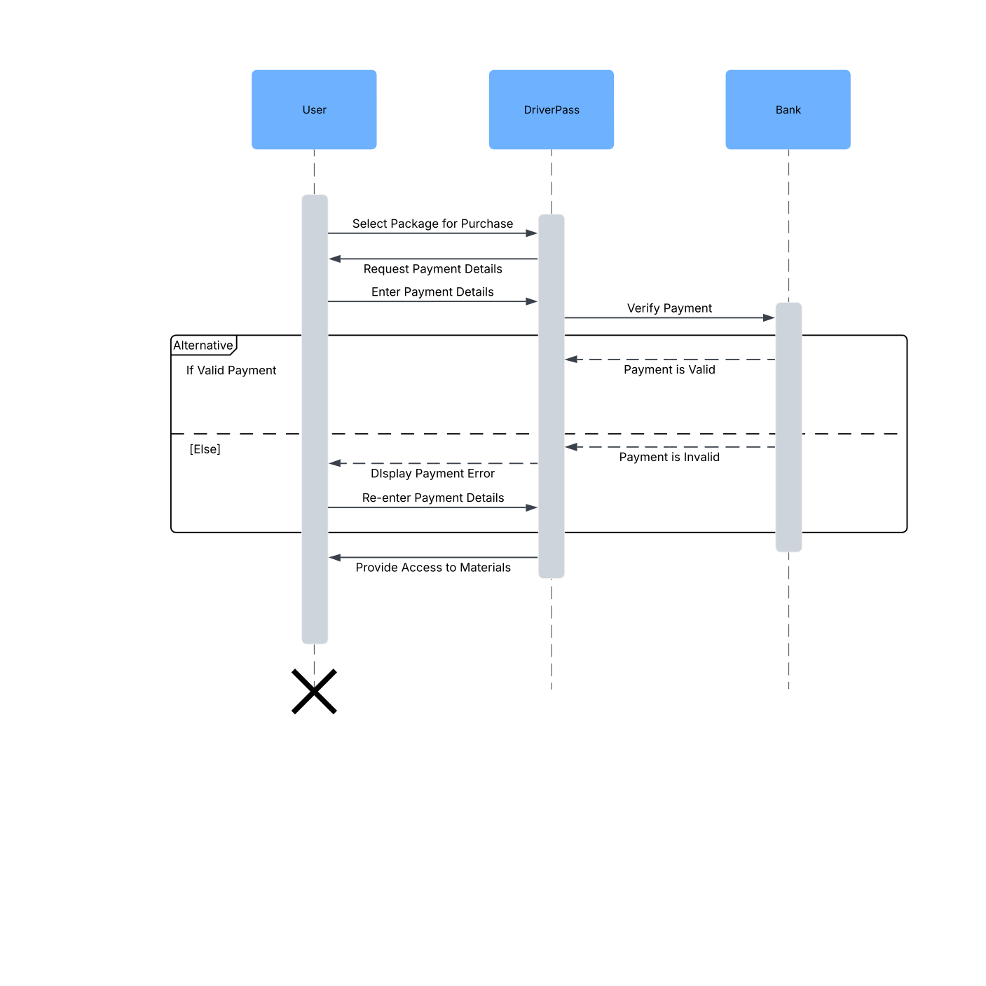

### UML Class Diagram

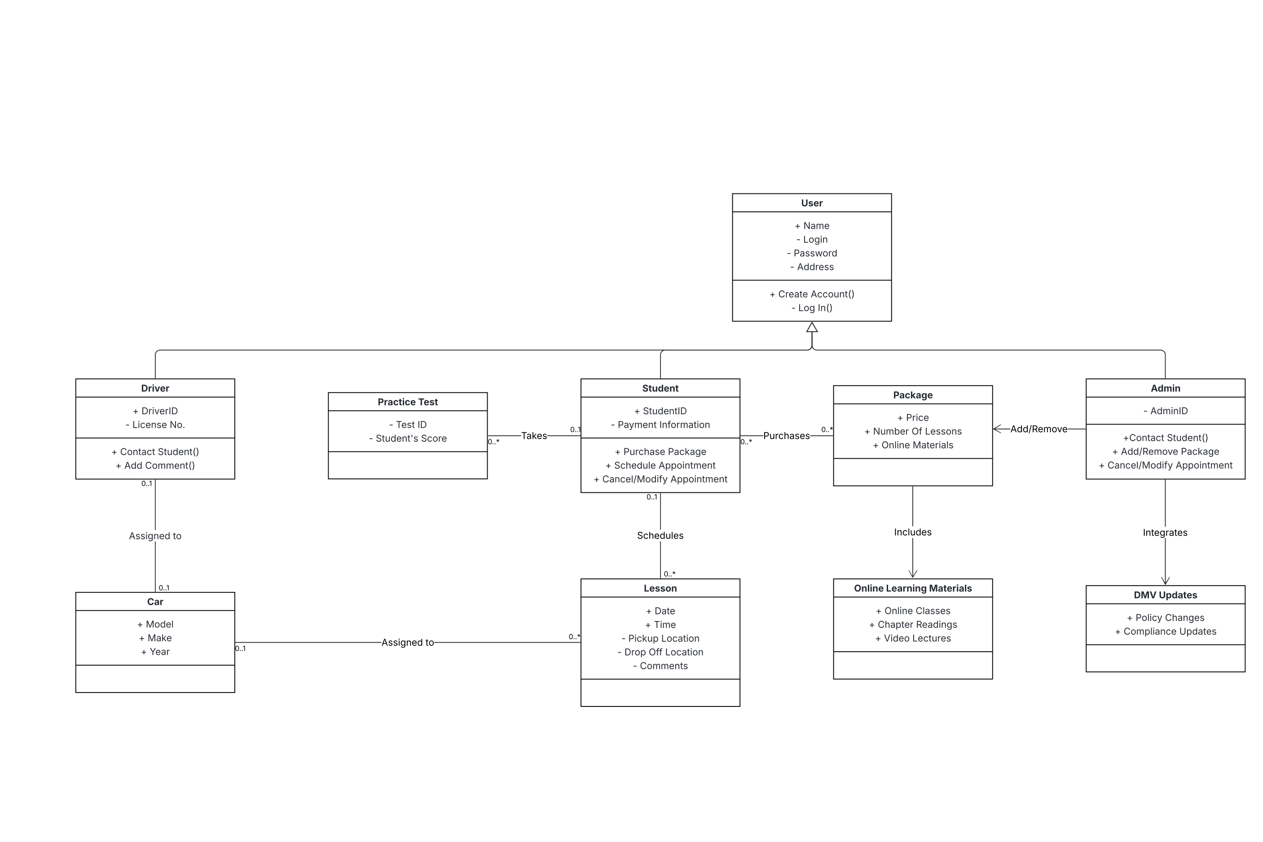

## Technical Requirements

• Cloud hosted infrastructure capable of handling many concurrent users, with scalable instances

to support peak user demand.

• Reliable internet connectivity for users (both students and drivers) and for data sync with DMV systems for updates.

• Operating system compatible with iOS, Android, Windows, macOS, and Linux through web

browsers.

• Relational Database Management System such as MySQL for managing users, lessons,

packages, and test data.

* RESTful APIs for DMV updates and payment verification systems.
* All data transmissions must use HTTPS with encryption of data.
* Secure account/login authentication using unique usernames and hashed passwords.
* Role based permissions and access control (Admin, Driver, Student).
* Automatic account lockout after 3 failed login attempts.
* Secure payment integration compliant with PCI standards.
* DMV API for regulatory updates and policy compliance.
* Logging and analytics tools such as Google Analytics for monitoring usage and errors.
* Routine updates and patching to be handled by IT Admin or system developer.

• Administrator access to manage users, lessons, and packages without modifying source code.